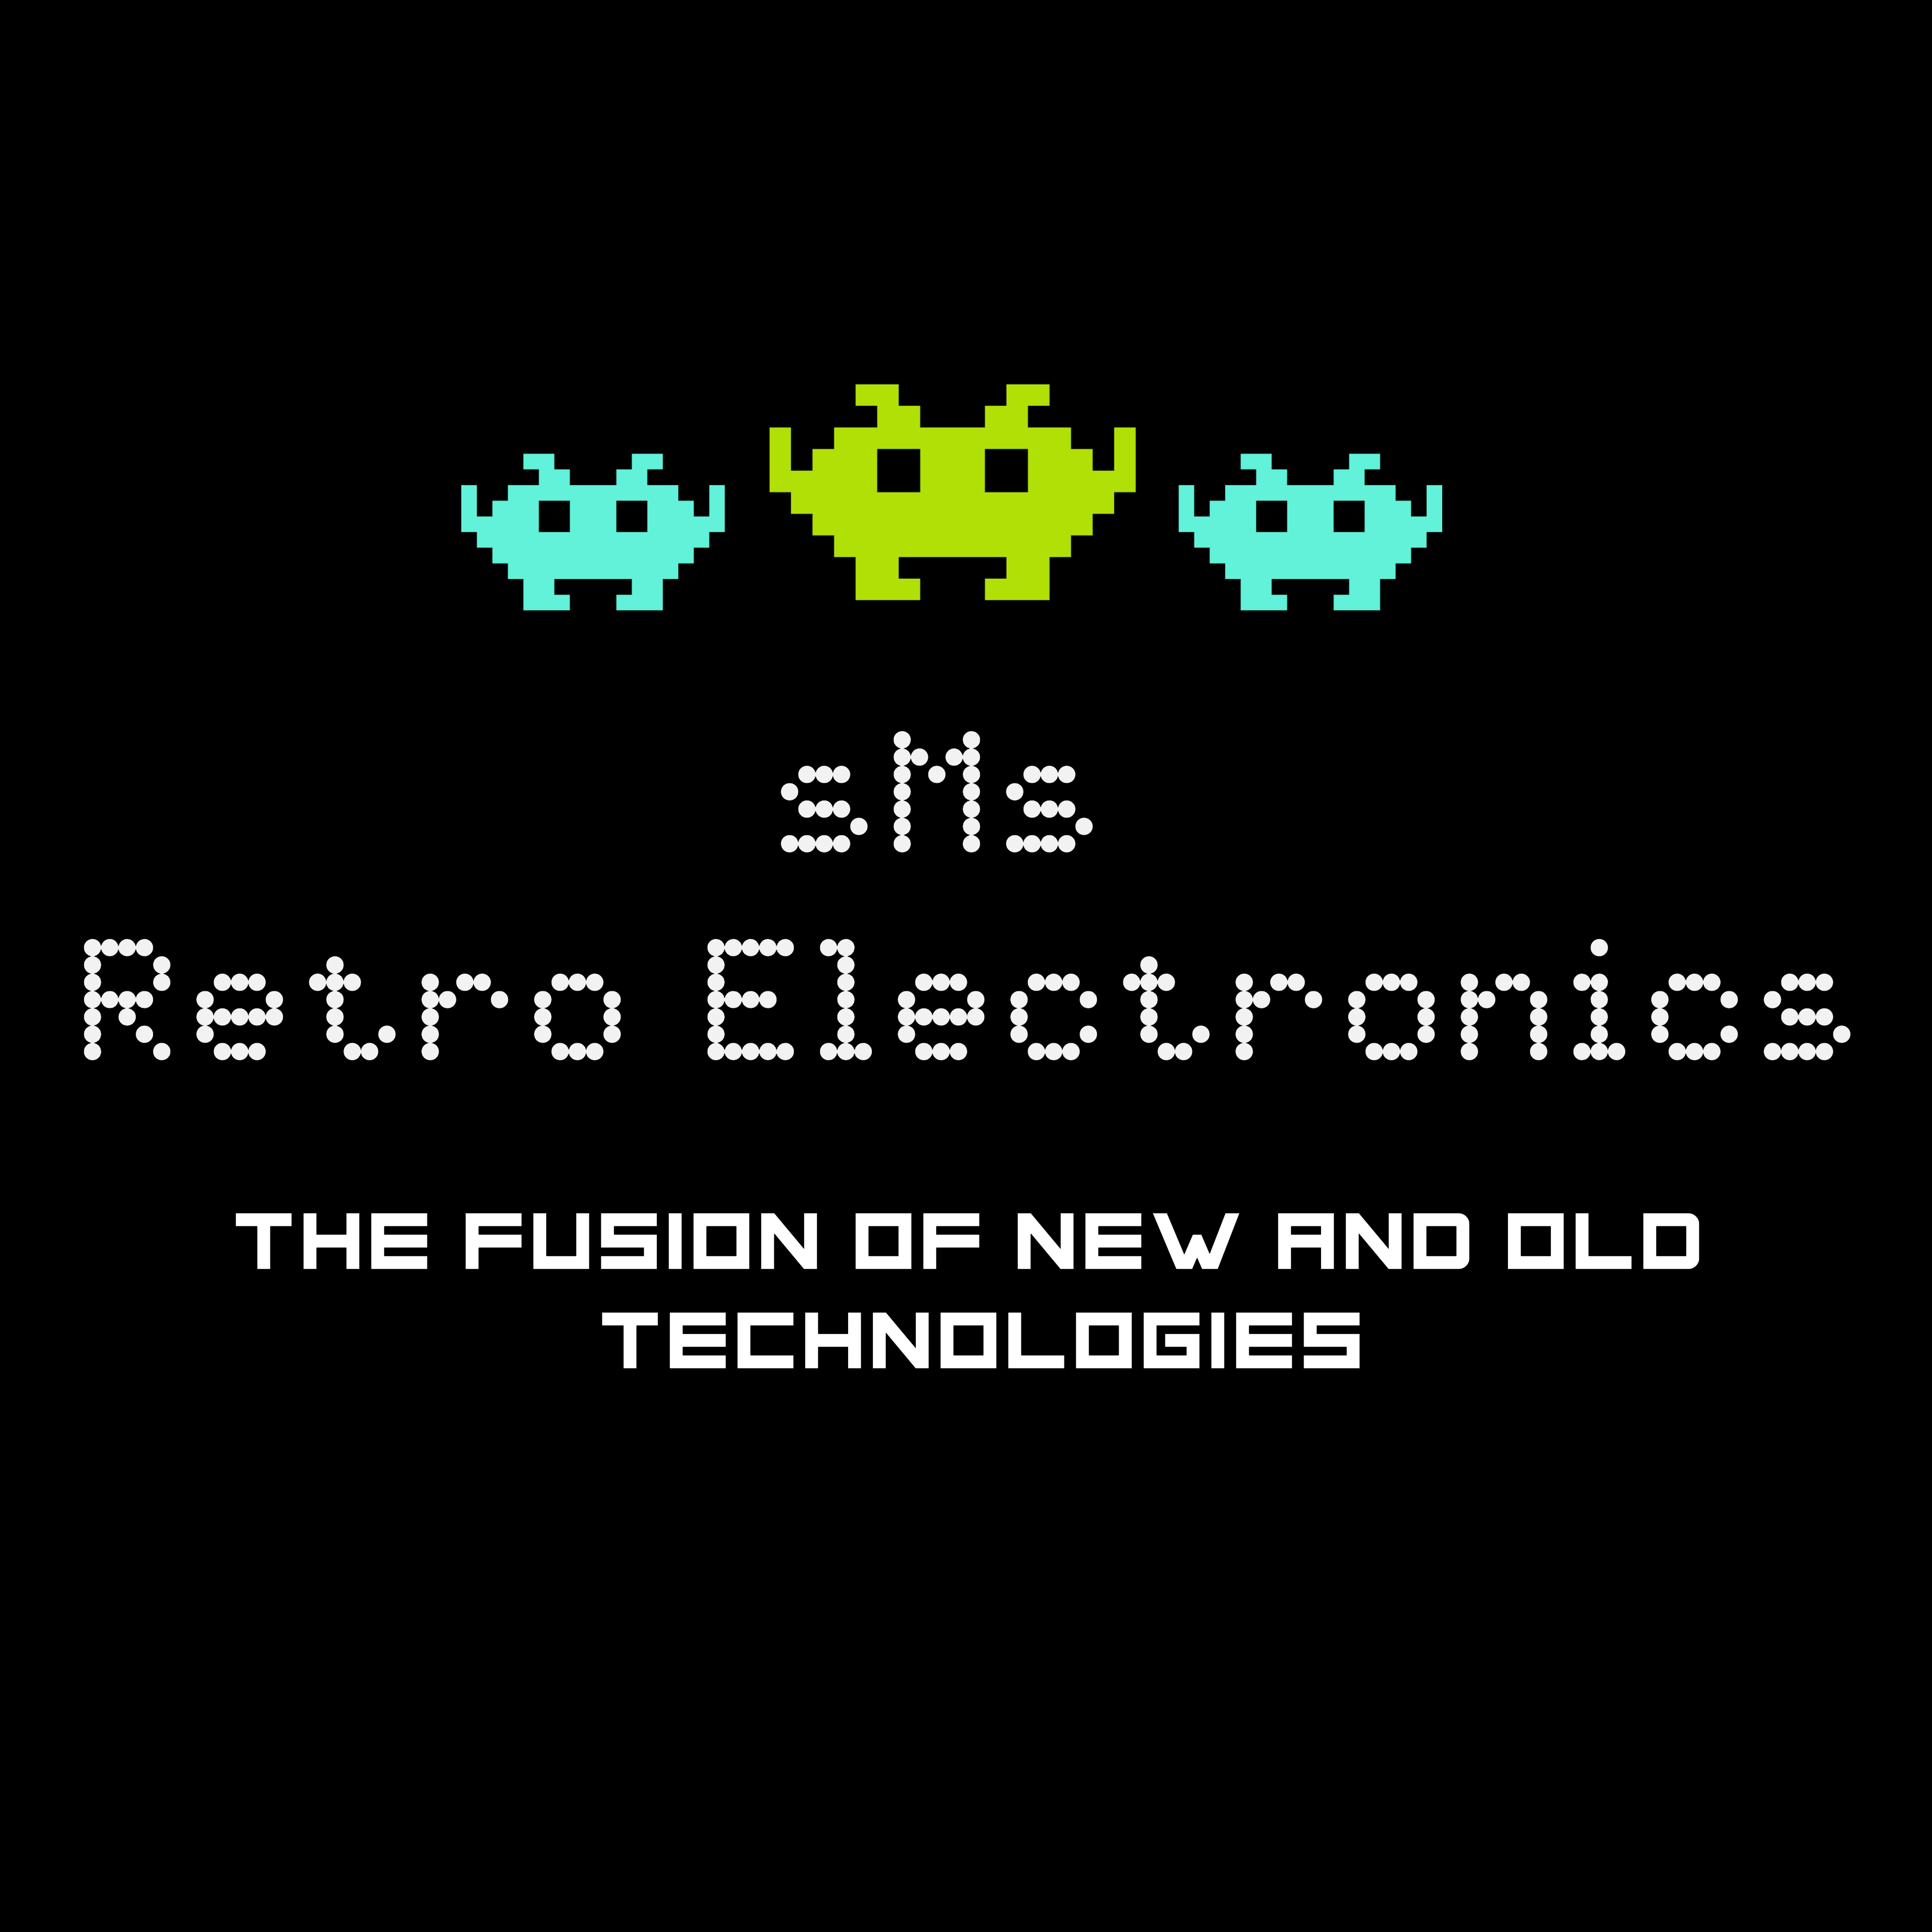

EVO64 KPS (Kawari Power Sequencer)
PC Board Version V1.0 : MCU Firmware Version V1.0
The document covers:
INSTALLATION & OPERATION

for Support: Bill Manganaro thex@optonline.net
or give a shout on the Discord channel: C64EVO, Expansions / Add-Ons

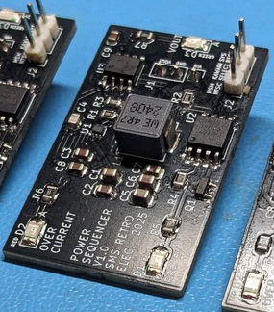

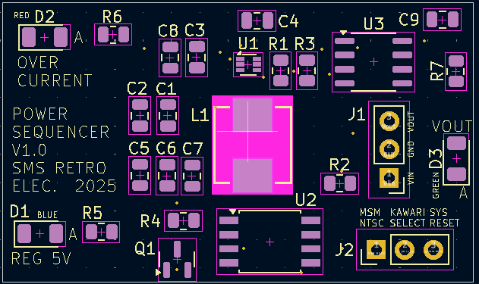

Whats is the Kawari Power Sequencer?

The Kawari Power Sequencer, known from here on as the “KPS”, is an electronically switched 5V regulator module that has been designed specifically for the EVO64 motherboard to work along side a Kawari VIC II and MSM. The KPS is a reliable, efficient, low noise, high frequency 5V switching regulator which remains very cool unlike linear regulators IC’s such as the common 7805.

The KPS is installed onto the EVO64 motherboard’s 5V “CAN” regulator location that supplies power only to the VIC II 5V VCC socket pin.

The KPS allows the user to switch video standards on your EVO64 Commodore 64 between NTSC and PAL via the “Multi-Switch Module” MSM and a Kawari VIC II LARGE or SMALL board using a simple keyboard command. It will switch the video standard and recycle the Kawari’s power in one operation. No longer will the user have to manually switch the computers power OFF and ON after setting the video standard with an MSM.

Over Current Safety Feature

The KPS incorporates an over current sensing circuit that will sense when the output current goes above 780 mA and turns the 5V output off. A RED LED will indicate this condition. The KPS will remain latched in over current state until the input voltage is turned off and the over current condition is removed.

This document illustrates all the details necessary to install the KPS, wire the necessary connections, and operate your KPS. The board you receive has been fully tested before shipping to insure that it works as designed.

Connector and Indicator Reference

1) Vout INDICATOR. - Green LED that indicates 5V power is present to the Kawari VIC II.

2) OVER CURRENT INDICATOR. - Red LED that indicates an over current condition is present.

3) REGULATOR INDICATOR. - Blue LED that indicates the internal 5V is working.

4) KPS INPUT AND OUTPUT CONNECTOR (J2)

PIN 1 [SQUARE PAD] LOGIC SIGNAL FROM MSM (INPUT)
PIN 2 KAWARI SELECT SIGNAL TO KAWARI (OUTPUT)
PIN 3 SYSTEM RESET SIGNAL (INPUT)

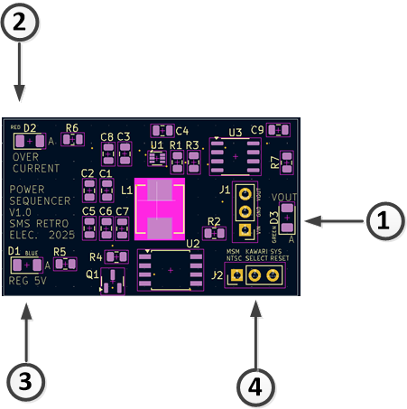

Overall View of Installation

The following diagram shows all the components necessary for the system to work.

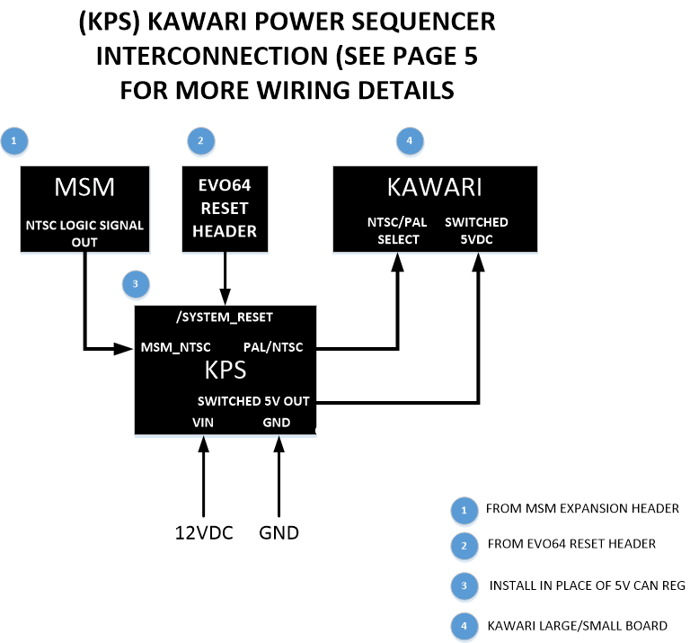

Detailed Installation

If a 5V regulator is already installed on your EVO motherboard, desolder it and clear the pad holes of any remaining solder. Install the KPS as shown below noting the position of the J1 pin header. Also, please read the “IMPORTANT SETUP LOGIC NOTES” so that you use the correct logic output (NTSC or PAL) from the MSM based on your VIC II emulation mode saved in the Kawari setup utility.

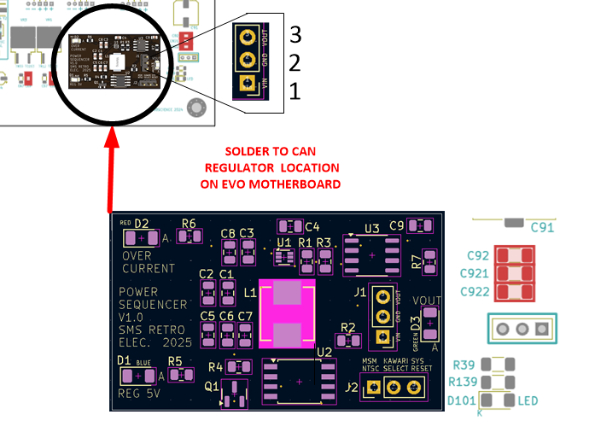

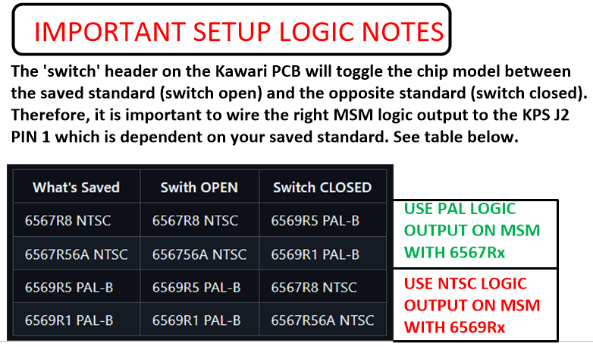

On your Kawari, if you do not have a VICII oscillator control module, set your clock select jumpers to “PCB Clock” as shown in the diagram below and connect the wiring as shown. Its important to check all the connections after you’re done.

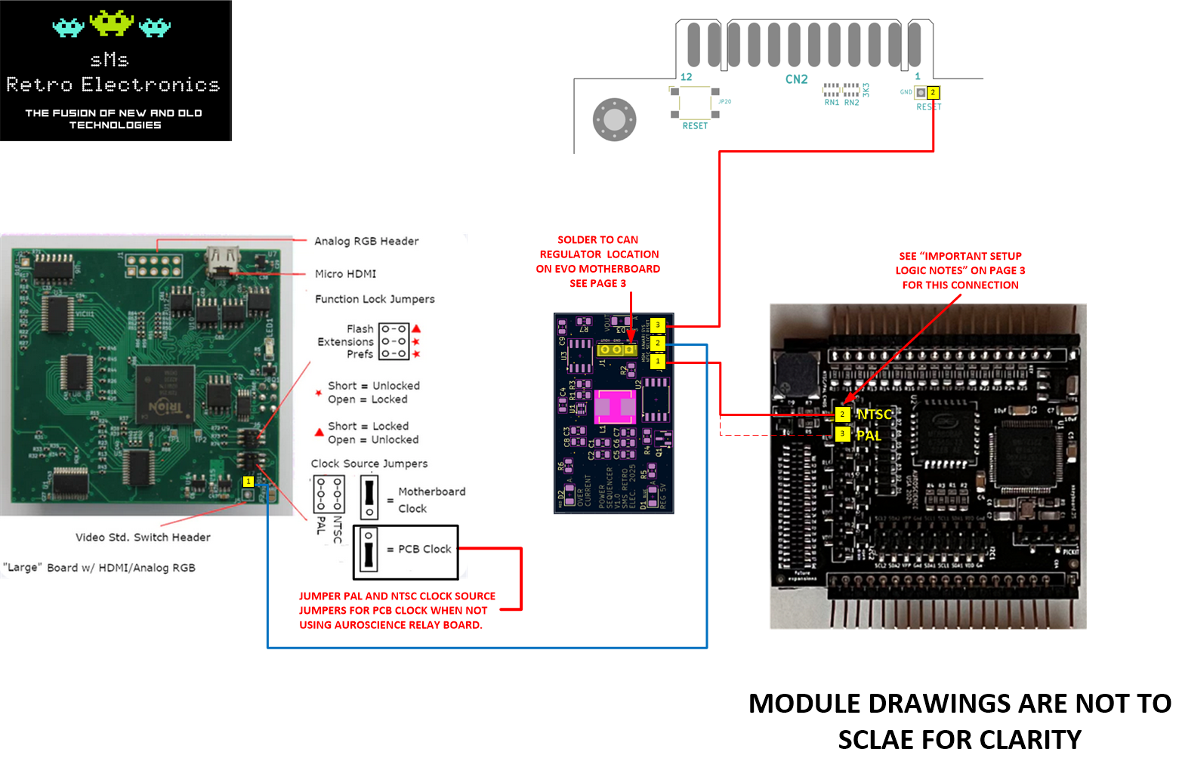

First Turn On

Setup your computer with an HDMI monitor connected (If using kawari Large) and turn the computer power on. On the KPS, the green LED (1) and blue LED (3) should be on and the red LED (2) should be off. Your kawari red LED should also be on. You should see a display like you normally do on your monitor. If you see this then you are in good shape. If the KPS red LED is on, and the green LED is off, this indicates an over current issue of >780 mA and must be investigated. The MSM LCD should look normal as shown with your current settings. We are interested in the VID: PAL or NTSC portion of the LCD. Your monitor should always reflect the setting shown on the MSM LCD.

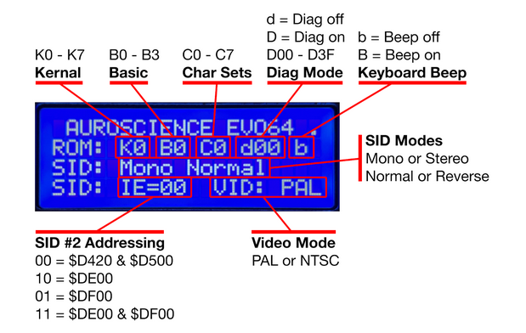

To change the VIC II video mode, see the instructions below. When changing the video mode, the KPS green and Kawari red LED’s will flash for about a second and then remain on. This indicates the Kawari power has been successfully cycled off then on in order for it to configure itself properly. The video output standard should now be what’s indicated on your MSM’s LCD. Here is a quick sanity check to make sure you are in the correct video standard. Type this BASIC command at the computer prompt and if it returns a “0”, you’re in NTSC. If it returns a “1”, you’re in PAL
PRINT PEEK (678)
Instructions to Change Video Mode on MSM:
VICII VIDEO MODE: video
This command enables you to toggle between PAL and NTSC, as long as you have all the necessary add-ons. To toggle between video modes, you simply enter the COMMAND MODE sequence (Reference below), followed by video and RETURN.
- After changing a video mode, Kawari will be automatically power cycled by the KPS module you’ve just installed.
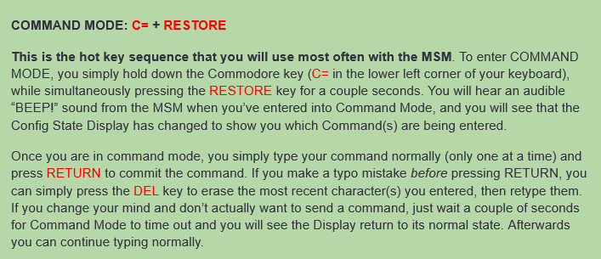
The web link to the full MSM documentation is located here:

WEB LINK TO : MSM DOCUMENTATION

If everything has worked than your installation has been a success. If things do not seem to be working correctly, then proceed to the following troubleshooting table.

TROUBLESHOOTING

SYMPTOM | ACTION
No LED’s on KPS are on | Check for 12V at the Vin of the KPS
Just the Blue LED is on | Check that the KPS is connected to the mainboard’s RESET header and that the connection is on the correct pin of the header
The red LED is on | The is a short at the KPS output. Remove the Kawari and see if the short goes away.
The power cycling does not occur | Check that the KPS is connected to the MSM “NTSC” logic output. Make sure the connection is on the correct pin.

